Release Assembly - TopCoder Cockpit DataTables Filter Panel and Search Bar Deployment Guide

Revision History
Author | Revision Number | Date
TCSASSEMBER | 1.0 | 11/15/2011

Deployment Instructions 3
1. Organization of Submission 3
2. Application Setup 3
2.1 Ant .Properties File 3
2.2 Build Scripts Setup 3
3. Database Setup 4
4. Deployment Instructions 4
5. Starting 4
6. Verification 4
7. Resource Contact List 5

Deployment Instructions

Organization of Submission

The submission follows directory structure provided below:

doc
Contains the Deployment Guide Document of this assembly.

direct
Contains sources and static files for Direct web application. This directory replicates the application development distribution structure and includes only updated and new files.
contest_service_facade
Contains the updated java source codes for component contest_service_facade
project_service
Contains the updated java source codes for component project_service
test_files
Contains the test_data.sql which inserts the test direct projects

Application Setup

The application is expected to be deployed to the following environment:

JRE 1.5
JBoss 4.2.3.GA
Informix DS 11.5

Ant .Properties File

No .properties files are modified.

Build Scripts Setup
The ANT build script for the components provides the following targets which are to be used:
- dist_tcs – recompile the component and package it into jar and deployed to the direct libs directory

You need to run ant dist_tcs against the 3 updated components before redeploying direct.

The ANT build script for Direct application (build.xml) provides the following targets which are to be used:

- switch-and-checkout – checkout or switch to the defined source code branches for all components defined in subprojects.xml
- dist-backend – rebuilt all the components from the source code.
- first_deploy – must be the first task to execute from command line. It will copy all dependencies to your local JBoss folder.
- deploy – should be the main task to execute from command line. It will build and deploy WAR file.
- deploy-static-files – deploys the static files to JBOSS.
- deploy-apache-static – deploys the static files to apache server on VM.

Please refer here for more information:
http://www.topcoder.com/wiki/display/docs/TC+Direct+Setup+Guide

Database Setup
- None

Deployment Instructions

This section provides the instructions in Production environment.

- Merge the code from submission into SVN branch for Direct application
- Merge the code from submission into SVN of project service
- Merge the code from submission into SVN of contest service façade
- Build and redeploy the component project service (use ant dist_tcs)
- Build and redeploy the component contest service façade (use ant dist_tcs)
- Build and deploy Direct application using ant deploy (or ant first_deploy ) command.
- Copy static files using ant deploy-static-files command or ant deploy-apache-static if use apache as static file server.

Starting

- Build and deploy the Direct application
- Run rm –rf /home/direct/jboss-4.2.3.GA/server/default/work/jboss.web/localhost/direct
- Start JBoss server instance hosting Direct application

Verification

How to set up the test data for verification
- Run test_files\ project_contests_test_data.sql on database to insert the test data of projects and contests
- Login into VM using account tc
- cd web/scripts/dwload
- run ./loadtcs.sh
- Run test_files\report_test_data.sql on database to insert the test data of reports

Use various browsers to open the link http://localhost:8180/direct or https://[vm_ip]/direct , login as heffan / password.

The first page to test is the dashboard active contests page

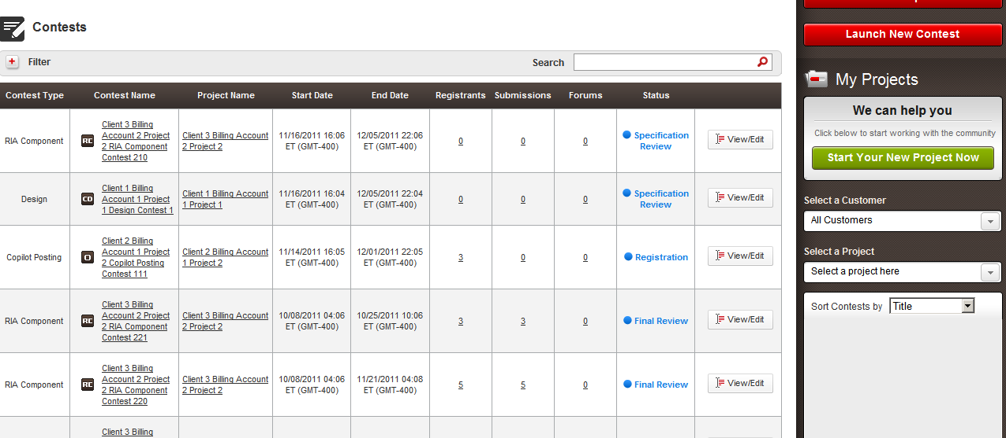

The filter is collapsed by default, click the + to open the filter panel

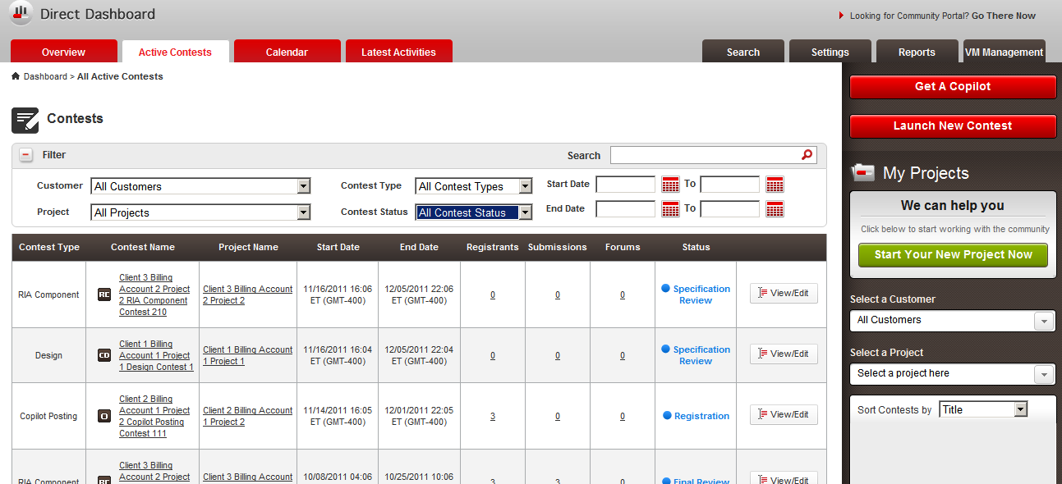

You can test the following filter controls:
- Customer
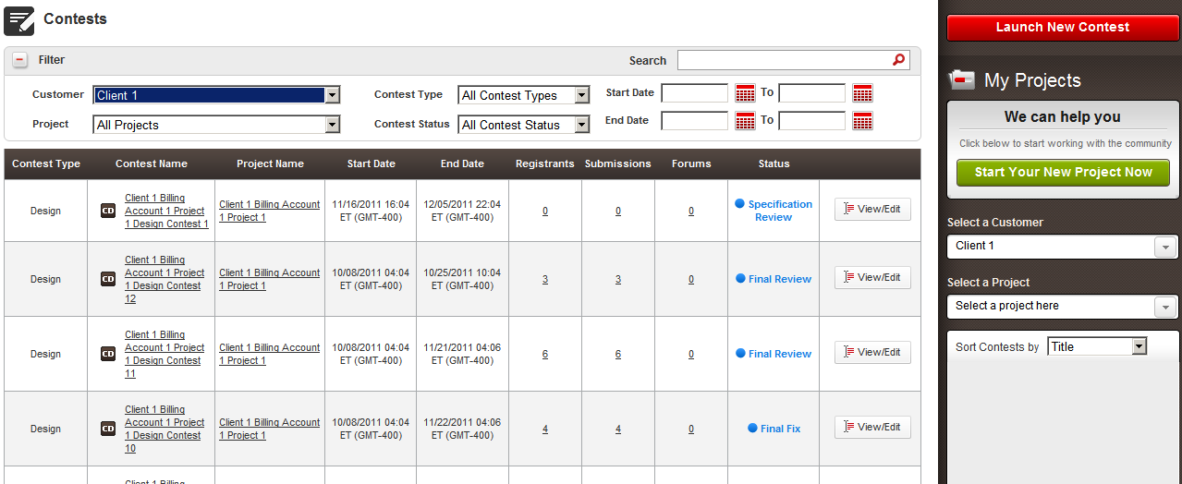
- Project
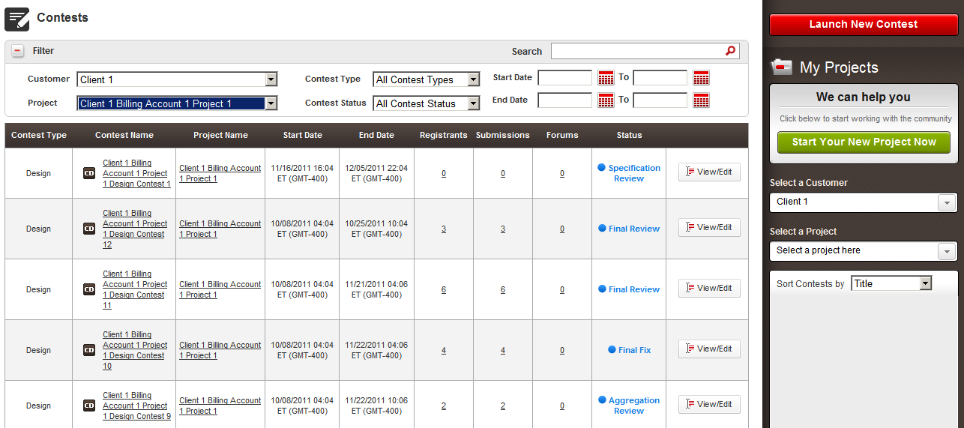
- Contest Type
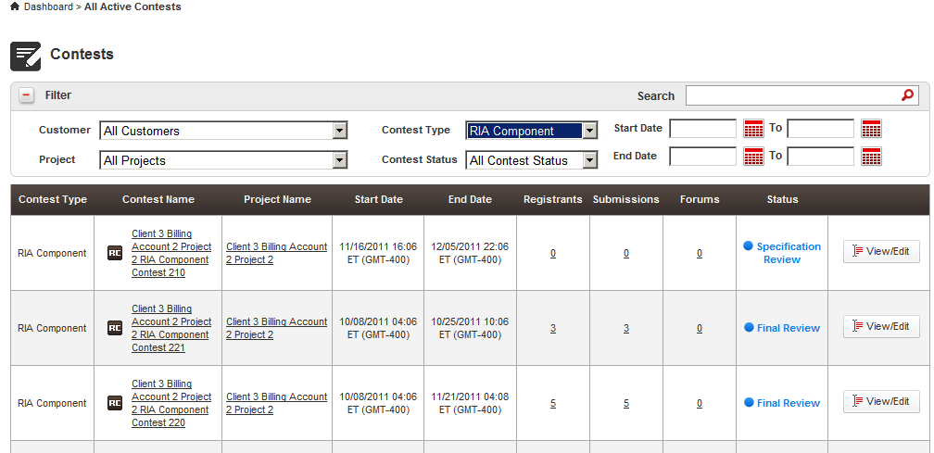
- Contest Status
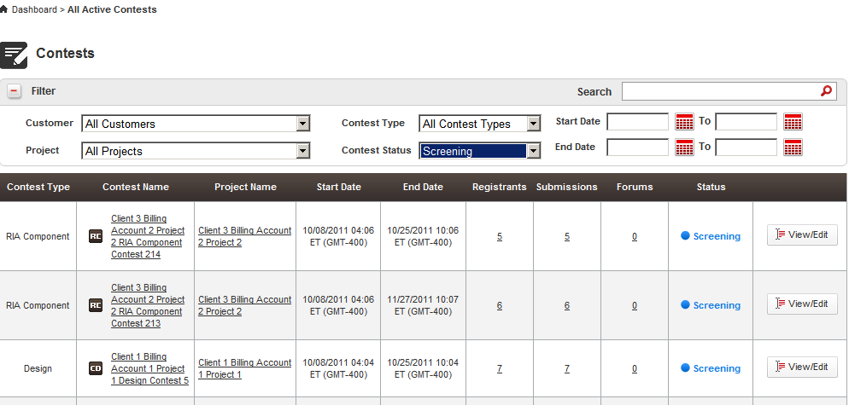
- Start Date (From To)
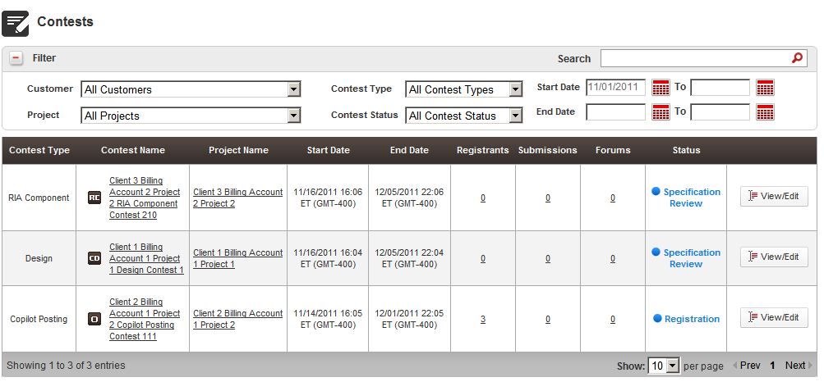
- End Date (From To)

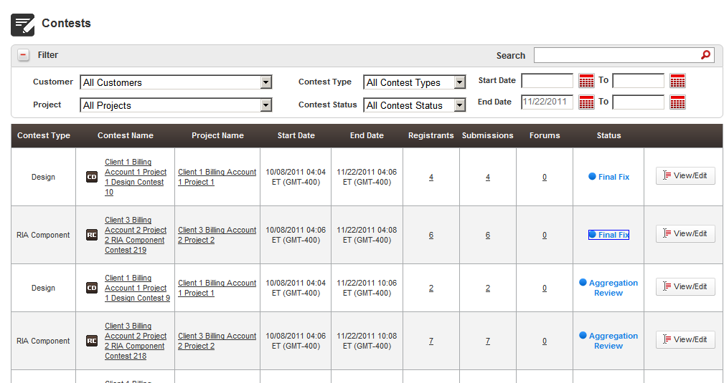

Check the search bar

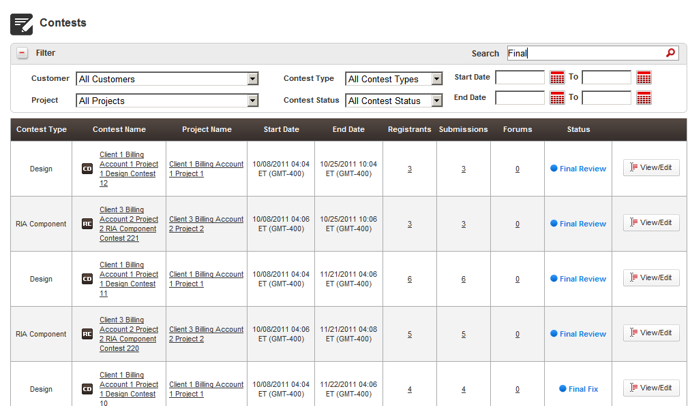

Go to the show all projects page http://[vm_ip]/direct/allProjects

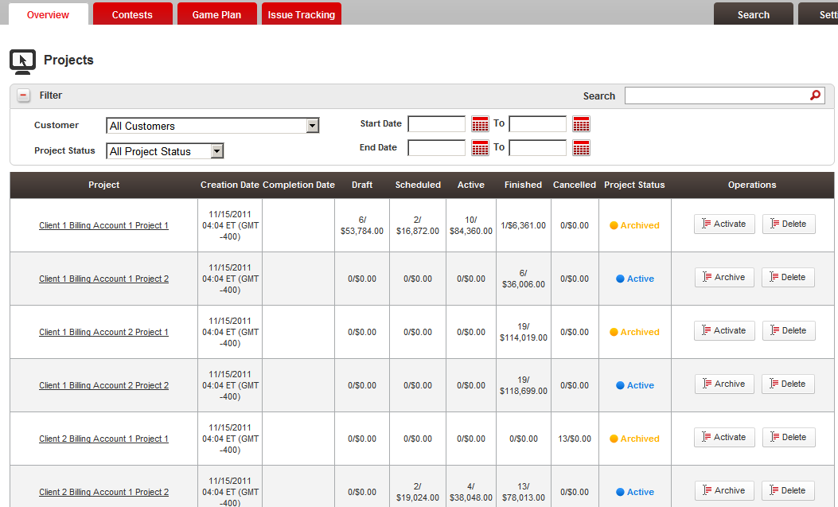

Test the
- Customer
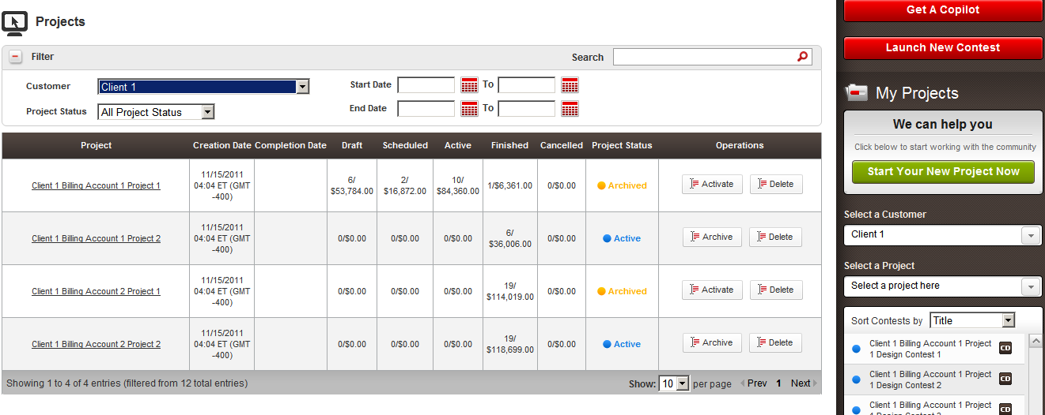

- Project
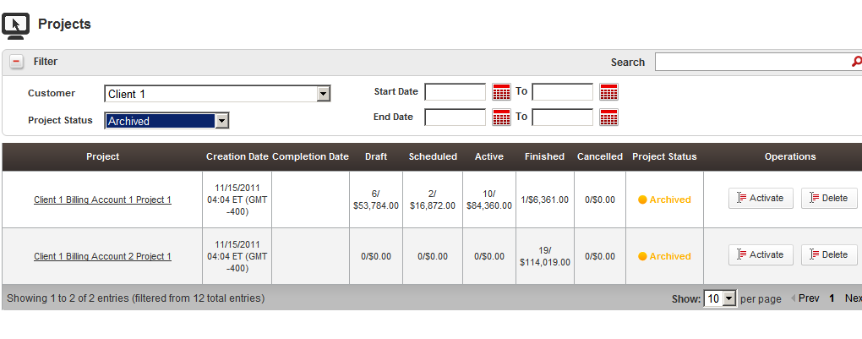

- Start Date

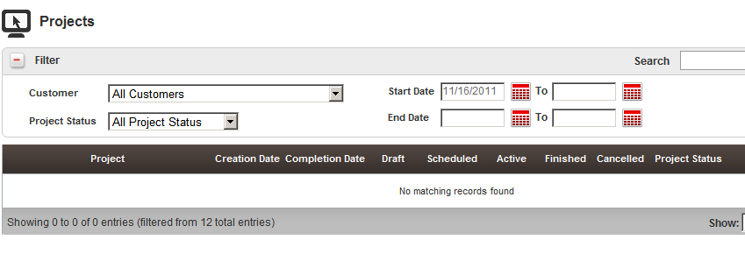

Search

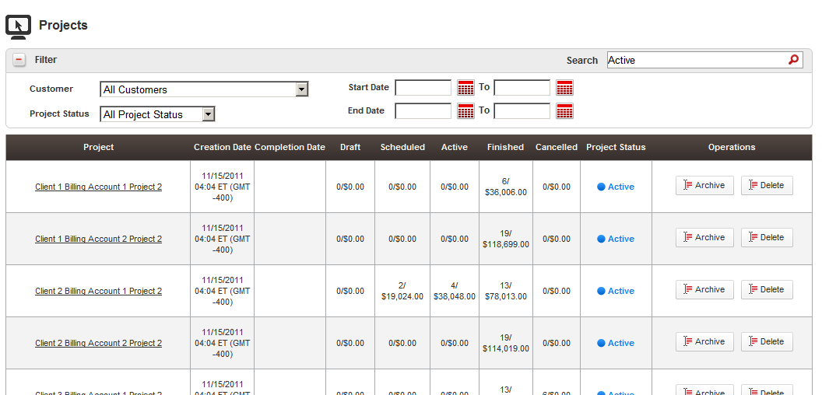

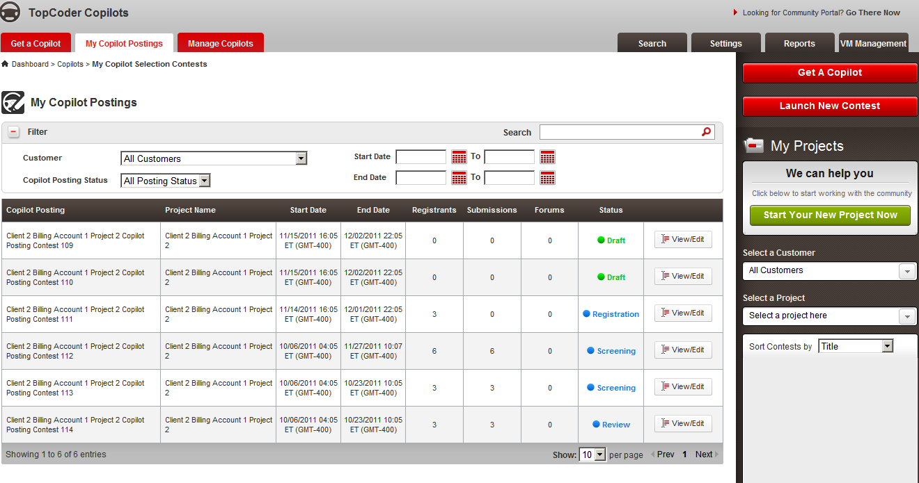

- Customer
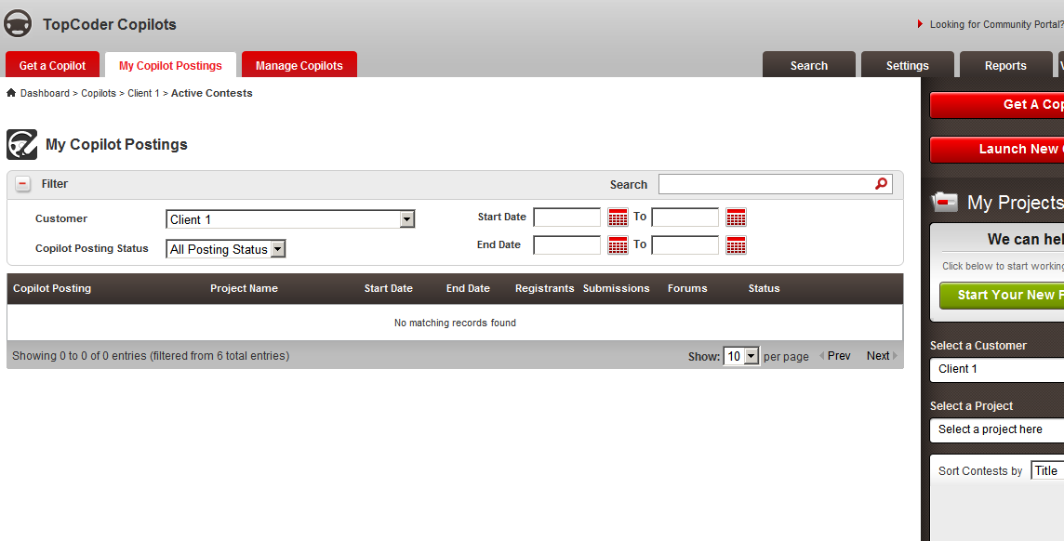

- Posting Status

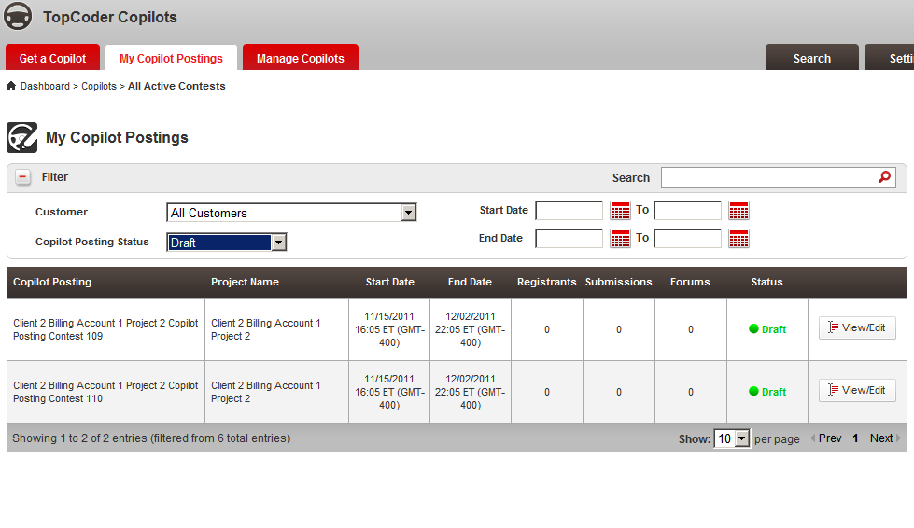

- Start Date
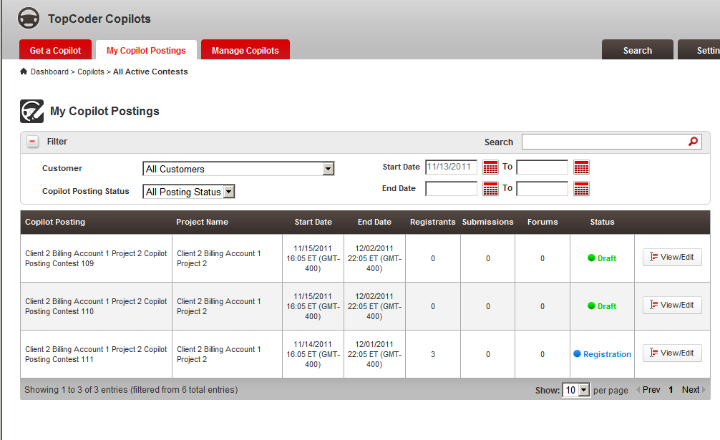

- End Date
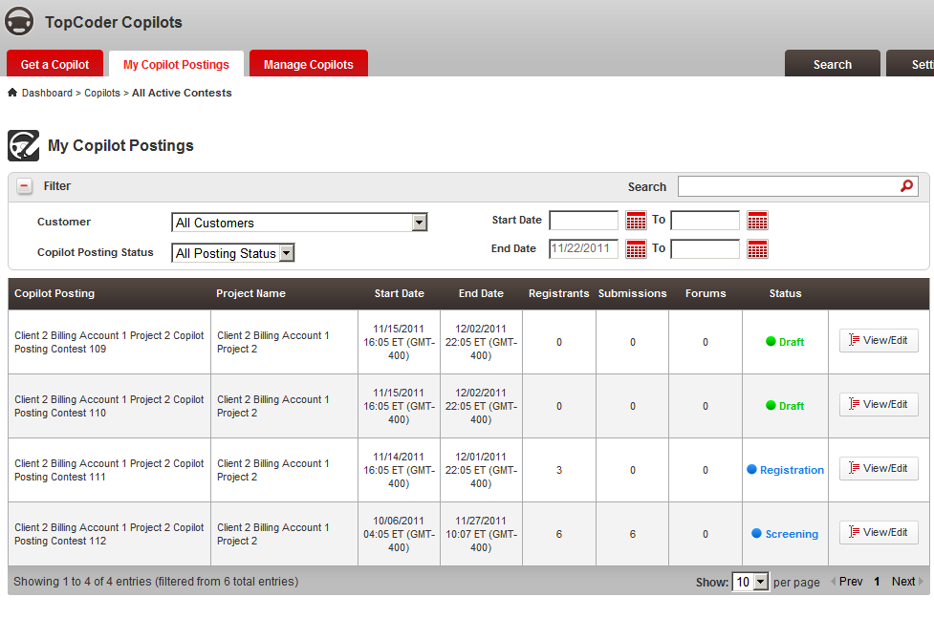
Search bar

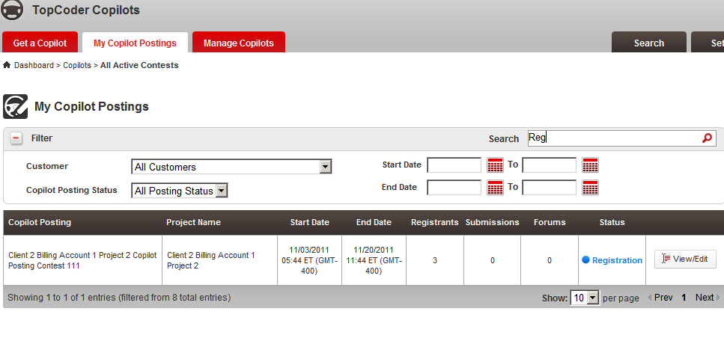

Pipeline report search bar

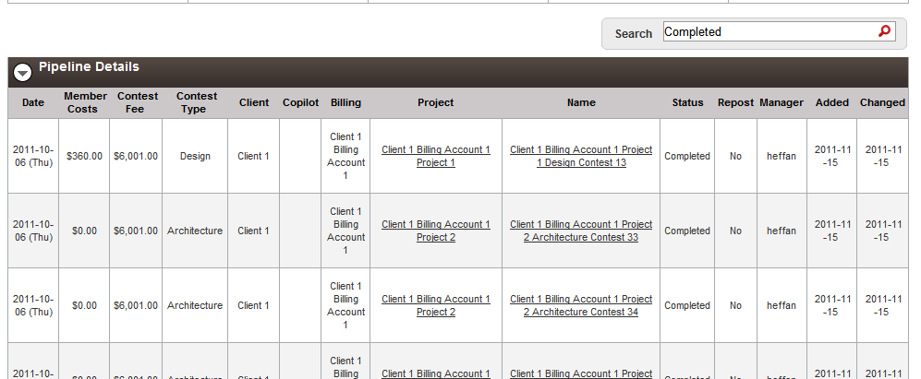

Cost report search bar

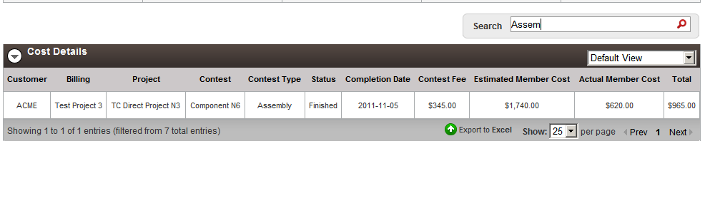
Billing Cost report search bar
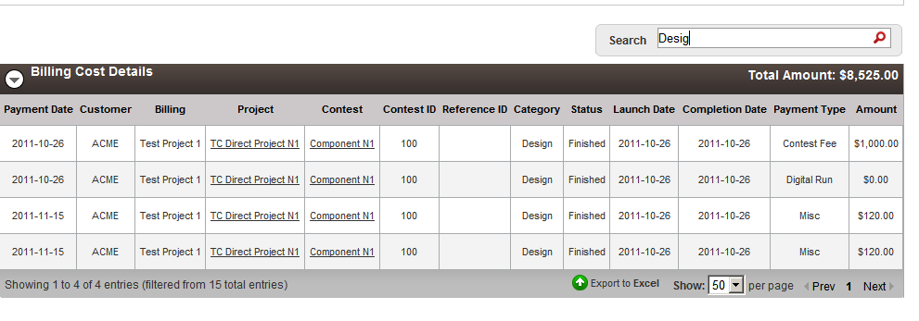

Resource Contact List

Name | Resource Email
TCSASSEMBER

